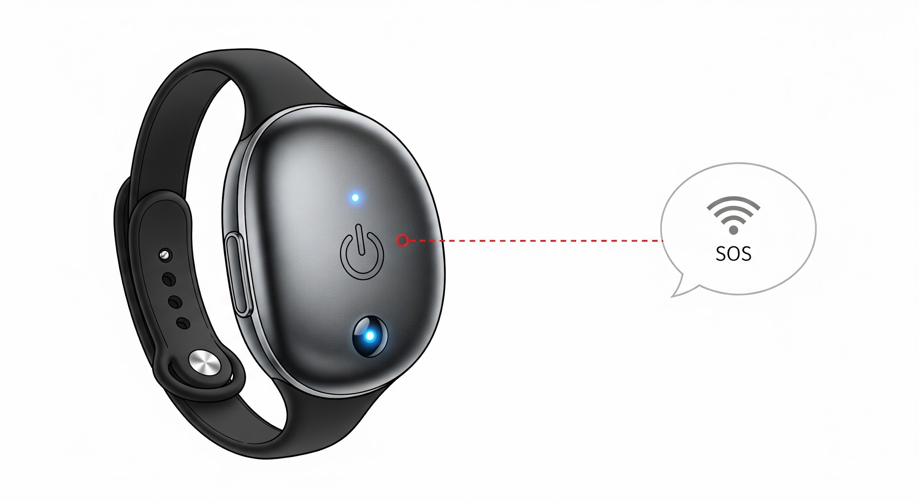

Provisional Patent Application — Full Draft Ready to File
This document contains the complete text and instructions needed to file your Provisional Patent Application for the WallyGuard device with the USPTO. Following these steps will grant you "Patent Pending" status for 12 months, protecting your idea while you seek funding and legal counsel.

Filing Instructions (2026 — Updated)
Detail | Instruction
Fee | $65 (Micro-Entity status applies to individual inventors)
Where to File | https://patentcenter.uspto.gov (Create a free account)
Time Estimate | 20–30 minutes for filing
Files to Upload | 1. Provisional Cover Sheet (PTO/SB/16). 2. Specification PDF (Convert the draft below into a PDF).

What to Upload
You must upload the following two files (PDF format preferred for the Specification):

- Provisional Cover Sheet (PTO/SB/16): Fill out the form using the text provided in Section A.
- Specification PDF: Copy the text from Section B into a clean document (Word/Google Docs), add simple sketches or drawings if you have them, and save it as a PDF.

A. Provisional Cover Sheet (Copy into Form PTO/SB/16)
Field | Content
Title of Invention | Closed-Loop Wearable Distress Communication and Safety Device (WallyGuard)
Inventor(s) | Person, Place, United States
Correspondence Address | Person, Place
Entity Status | Micro Entity (I qualify under 37 CFR 1.29)
Application Type | This is a provisional application under 37 CFR 1.53(c).
Attached Specification | Yes (detailed written description + drawings)

B. Full Specification (Copy into Word → Convert to PDF)

Title: Closed-Loop Wearable Distress Communication and Safety Device (WallyGuard)
Inventor: patricia Sanford, 1133 Rockfish Drive, United States

Cross-Reference to Related Applications: None

Background of the Invention
Non-verbal individuals (e.g., severe autism) and vulnerable adults (dementia, nursing home residents) face a high risk of abuse and neglect in schools, buses, and care facilities due to the lack of an objective witness. Existing devices like AngelSense are banned in schools due to COPPA, wiretapping laws, and privacy concerns because they record or transmit raw audio.

Summary of the Invention
The WallyGuard is a wearable device using a "closed-loop" system that detects distress patterns (audio, visual, or biometric) locally on the device and transmits only metadata alerts (time, location, trigger type) to caregivers — without ever recording or storing raw audio or video. This design is intended to legally classify the device as a protected "communication device" under the Americans with Disabilities Act (ADA) rather than a surveillance device, ensuring its use as a reasonable accommodation in critical environments like schools.

Detailed Description

Core Closed-Loop Technical Design
The device is designed with the following elements to function as an Augmentative and Alternative Communication (AAC) device while mitigating privacy risks:

- Audio Processing: Local on-device detection of phrases (e.g., "help now") or prolonged distress sounds (e.g., sustained high-pitch vocalization) that constitute an obvious threat. The processing is done entirely on the device.
- Data Recording: Explicitly NO raw audio or video is stored, recorded, or transmitted off the device. Raw audio is immediately deleted after local processing.
- Transmission: Only alert-only metadata is transmitted to an authorized caregiver/guardian application. Metadata includes time, location, and the specific distress trigger type, but never raw audio or video.

New Design Features
The final design will include multiple options to enhance safety and user tolerance:

- Biometric Refinement: Integration of additional biometrics, specifically pulse and heart rate, to provide a more objective data point to accompany a distress alert.
- First-Responder System: Inclusion of a passive NFC/QR chip or signal that first responders can scan to immediately alert them that the individual is a vulnerable person (non-verbal, mentally disabled), prompting them to stop, think, and observe before escalation.
- Multiple Sensory-Friendly Form Factors: The device will be available in multiple styles to accommodate sensory issues and tolerances: Watches, small pins, luggage-type tags, AirTag-like tags, and ankle placements.
- Visual-Only Pivot Option: An alternative model or setting designed for environments where audio detection is completely banned, utilizing local visual-detection of distress patterns (e.g., collapse, rapid motion) without storing raw video.

Legal Strategy
The core legal strategy frames the device as a necessary tool for accountability and communication:

- Classification: Classified as an AAC (Augmentative and Alternative Communication) device under ADA Title II and the Individuals with Disabilities Education Act (IDEA), ensuring a non-verbal user's right to effective communication of distress and safety needs.
- Mission: To provide objective documentation (metadata) to ensure Fair and Adequate services under FAPE, restoring trust and ensuring accountability where neglect or abuse may occur.

Drawings
The following drawings are attached to further describe the invention:

Drawing/Figure | Description
Figure 1 | System architecture diagram (closed-loop flow of audio processing to metadata transmission)
Figure 2 | Illustrative drawing of the multiple form factor options (watch, pin, tag, ankle)
Figure 3 | Metadata alert flow diagram (Device → Cloud → Caregiver App)

Claims
None required for provisional application.

End of Specification

